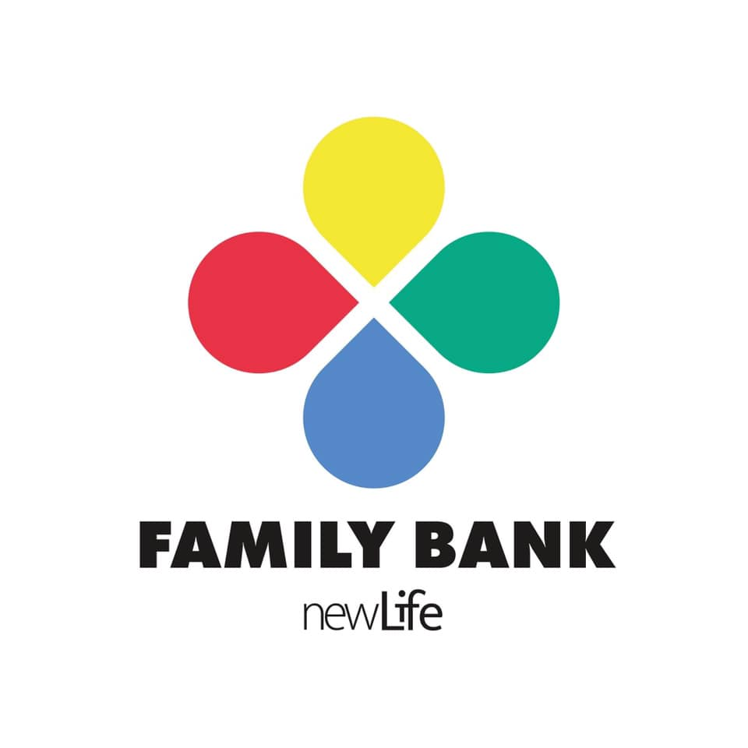
Uniform Drop off points:
Dunelm : Holyrood Drive, Skippingdale Industrial Estate, Scunthorpe DN15 8NN
Morrisons: Lakeside Parkway, Scunthorpe DN16 3UA
New Life Church: 18 Brumby Wood Ln, Scunthorpe DN17 1AB
Family Bank: 203-205 Frodingham Rd, Scunthorpe DN15 7NH (Thursday - Friday 10 am - 4pm
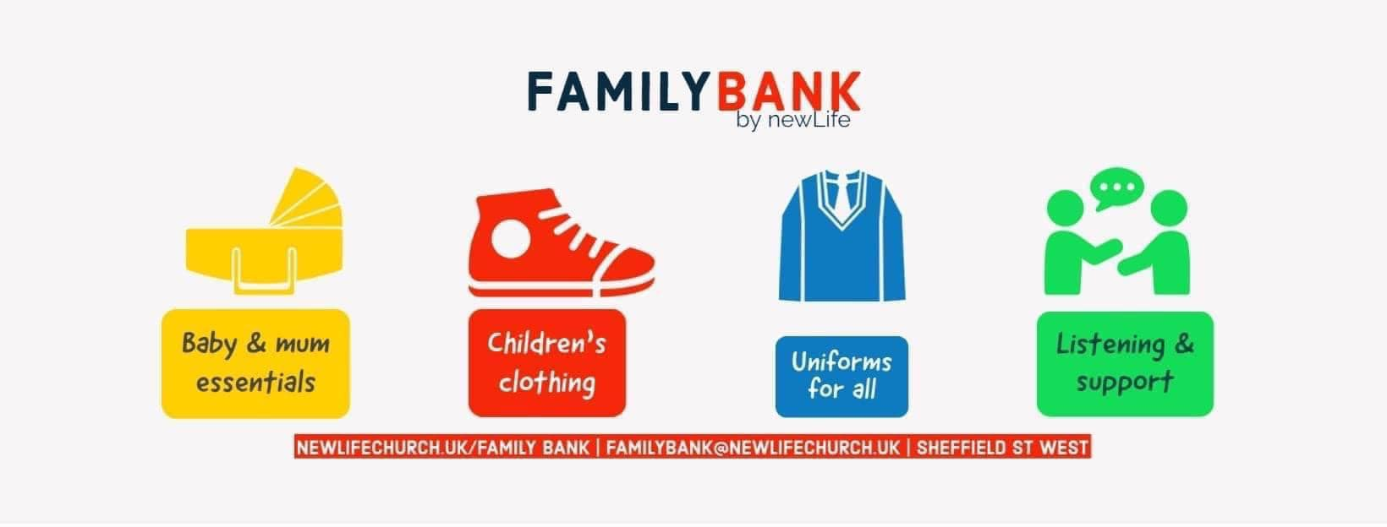


Saturday 27th August 2022
10am-12pm, 2pm-4pm
Crosby One Centre
Digby Street, Scunthorpe DN15 7LU
֍Free uniforms for all֍
Whilst every effort is made to ensure a full uniform for your child, it may not always be possible to find every piece of item.

