1 July 2022

Welcome to Our Lady of Lourdes Catholic Multi-Academy Trust

Dear Parents and Carers

Following on from a letter you received from Peter Giorgio, Director of Education at the Diocese of Nottingham, I am delighted to welcome you formally to the Our Lady of Lourdes Catholic Multi-Academy Trust family. St Bede’s Catholic Voluntary Academy transferred into the Our Lady of Lourdes Catholic Multi-Academy Trust on Friday 1 July 2022. Over the coming months all of the Catholic schools in Lincolnshire will join the Catholic schools across Nottinghamshire as part of the Our Lady of Lourdes (OLoL) CMAT.

The Our Lady of Lourdes CMAT has been working closely with the schools in the St Thérèse CMAT for the last 18 months and the transfer of the Lincolnshire Catholic Schools into OLoL formalises this strong relationship.

The Trust provides many opportunities for teaching and support staff in all the schools to work closely together to support and learn from each other to ensure that your child receives the very best Catholic education. In practice, little will change for you and your child(ren). We will continue to offer a strong faith-based education, placing the life, teachings and example of Jesus Christ at the centre of all we do, caring for your child(ren) and prioritising their safety, well-being and all round development, so that they can flourish in school and once they leave. If you would like to learn more about our Trust, please visit our website: www.ololcatholicmat.co.uk

Finally, I would like to thank you for your support. Our schools are wonderful places and the support we receive from families is invaluable!

With prayers and good wishes

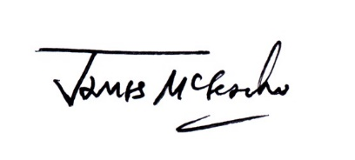

James McGeachie
CEO, St Thérèse of Lisieux Catholic Multi-Academy Trust

