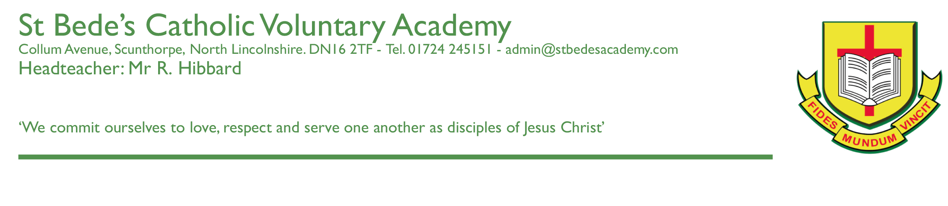

Dear Parents & Carers

We would like to invite you to attend our second Year 11 Parents’ Evening on **Thursday 26th January 2023** from **3.30pm to 7pm**.

As Year 11 is a crucial year, we strongly encourage all parents and students to attend this important consultation with school staff.

Appointments can be made immediately and booking will close on Thursday 26th January at 12noon. Appointments are available on a first come first served basis.

As part of the evening, Ms Taylor (our Careers adviser) will be holding a ‘surgery’ in the Learning Resource Centre designed to answer any careers or progression routes questions that you may have. Please do feel free to make use of this valuable opportunity.

While appointments will be held in person at the academy, all appointments will be booked through the online ‘School Cloud’ system which you will be familiar with from previous occasions.

Please visit https://stbedescva.schoolcloud.co.uk to book your appointments. (A short guide on how to add appointments is included with this letter.) Login with the following information:

**Student’s First Name**

**Student’s Surname**

**Student’s Date of Birth**

Further details and a link to our School Cloud site can be found here: <https://stbedesscunthorpe.org.uk/parent-consultations/>.

If you do not have access to the internet, please contact the academy office who will be happy to add appointments on your behalf.

Yours sincerely

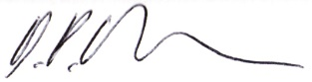

Mr D Fields

**Assistant Headteacher**