Dear Parents and Carers,
We hope this email/letter finds you and your family in good health. We are reaching out to you today to invite you to participate in our annual survey aimed at collecting your valuable information and views regarding your child's education and the overall school experience.
At Our Lady of Lourdes Trust, we firmly believe that parental engagement is a foundation of our pupils’ success. Your perspective, opinions, and feedback are invaluable to us in shaping the educational journey of your child and enhancing the quality of our school and wider Trust community.
To ensure that your views are listened too we launched an online survey last year. This survey was very successful and has helped us collect vital information from our parents across our trust. Due to its success we would like to again, provide you with an opportunity to share your thoughts on various aspects of your child's education, the school environment, and areas where we can further improve.
By participating in this survey, you contribute to the continuous growth and development of our school community. Your insights will continue to help us:
- Understand your needs and aspirations: Your feedback will provide us with a deeper understanding of your child's experience at school.
- Further strengthen communication and collaboration: We are committed to encouraging open and transparent communication between our school and parents. Your input will help us identify ways to improve our communication channels.
- Continue to enhance our strategies and initiatives: Your feedback is important to us.
We value your time, and we have ensured that the survey is user-friendly and can be completed conveniently. The questions cover a range of topics and will only take 5 minutes to complete. Your responses are anonymous.
To access the survey:
Either access the below QR Code: | Or the below website address:
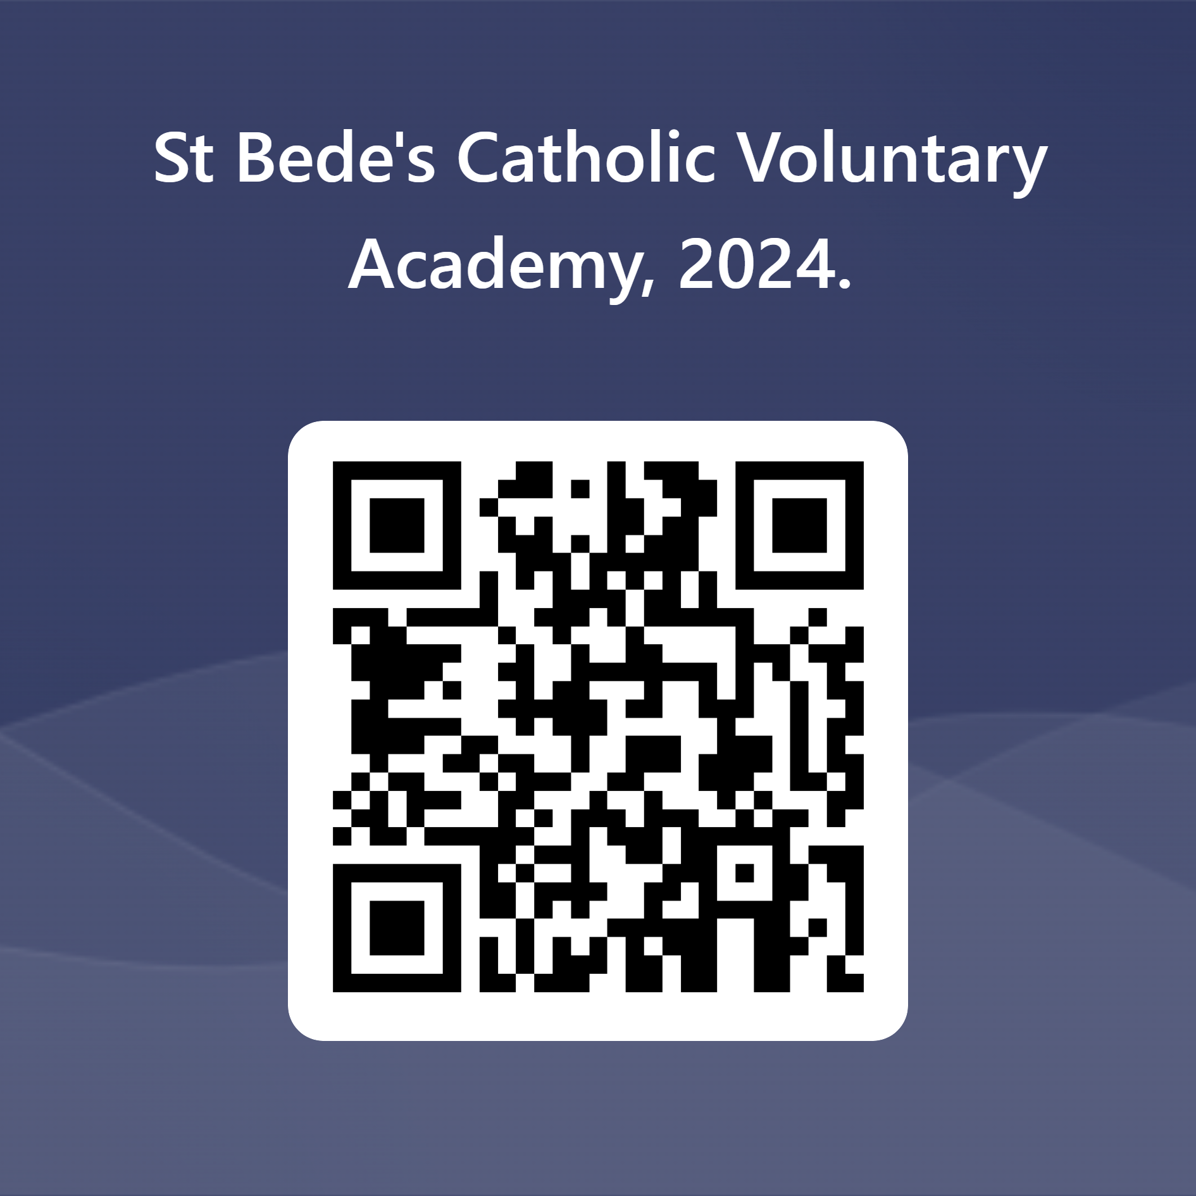 | https://forms.office.com/e/apfSiGtyrq

We kindly request you to complete the survey by 19th July, as this will allow us to analyse the results and carry out necessary changes quickly.
Your active participation in this project is invaluable, and we greatly appreciate your time and effort in providing us with your honest feedback. Together, we can create an even more enriching educational experience for our students.
If you have any questions or require further information, please feel free to contact your school.
Thank you for your continued support and partnership in your child's education.
Best wishes,
Robert della-Spina

