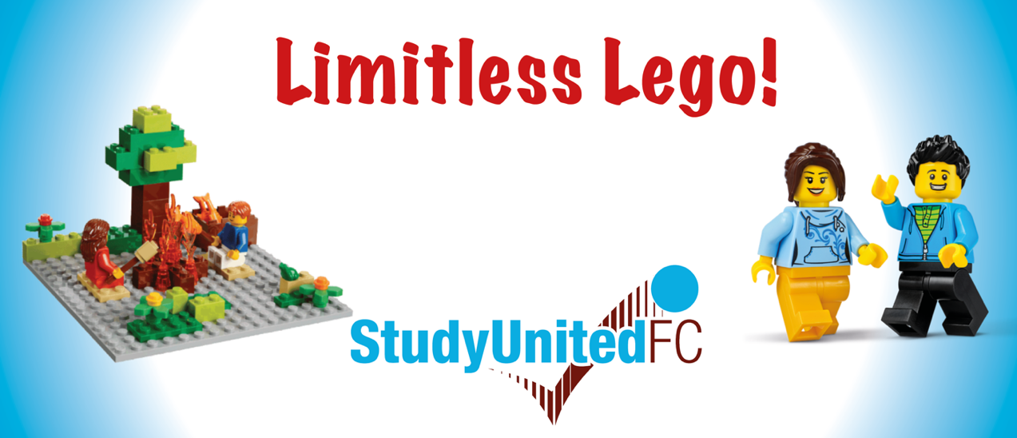

Join us for a fun and exciting session for service children at
The Armed Forces Hub
Using our Limitless Lego sets, create your own story and take pictures along the way. You will then use them to create your own Lego comic in the Lego Story Visualiser app on our iPads.
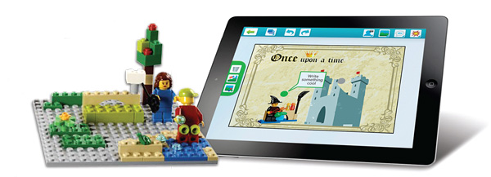

Tuesday 22nd October
13:30 – 15:30
Suitable for ages 7+
Session length - 2 hours
Cost – FREE

Parental supervision is NOT required

Book your place here Limitless Lego - Armed Forces Hub Tickets, Tue 22 Oct 2024 at 13:30 | Eventbrite



