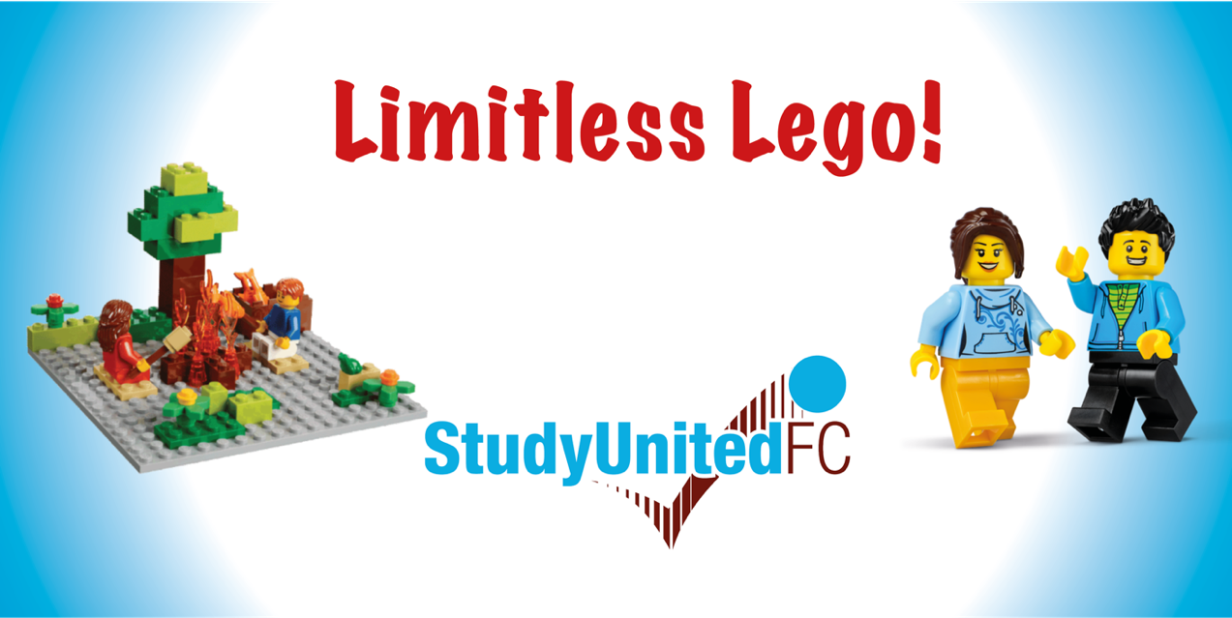

Join us for some fun and exciting half term sessions at our Study Centre at The Attis Arena (Glanford Park)

We have two sessions available this half term.

Sphero Robotics

Monday 21st October

13:00 – 14:30

Suitable for ages 8+

Cost £3.00

Cost – £3.00

Limitless Lego

Tuesday 22nd October

09:30 – 11:30

Ages 7+

Cost £3.50

For Eventbrite booking links, check out our website

[www.studyunited.org.uk](http://www.studyunited.org.uk)

